Emergency Department Operations
A multi-stage discrete-event simulation and factorial study
Statistical Modelling and Design of Experiments (SMDE)
⟨ author names ⟩
⟨ date ⟩

Contents

1 Executive summary
Running an emergency department (ED) efficiently means balancing the cost of staffing against the time patients spend waiting, a trade-off that is expensive and risky to explore on the real system. Computational models offer a cheap, safe way to test many operating scenarios and extract quantitative insight.
In this project we build a discrete-event simulation (DES) of an ED modelled as a three-stage open queueing network — triage, treatment, and admission — and use it to study how staffing decisions affect the daily operating cost. The simulation uses an event-scheduling engine and is parametrised in Kendall's notation, so each stage is a configurable M/M/c station and the stages compose into a network.
Validation is treated as a first-class concern. The pseudo-random number generator that drives the model is verified with a statistical test battery (mandatory), and the model itself is validated three independent ways: against the closed-form Jackson-network solution, against an equivalent GPSS model, and through event-trace inspection. A full-factorial 2³ experimental design then quantifies which staffing levers matter. We find that adding a triage nurse and a treatment doctor are the dominant cost reducers, while a second admission clerk has no significant effect — a conclusion that agrees with the congestion predicted by queueing theory, which itself reinforces the model's validity.

2 System description
The system modelled is a single emergency department that processes a stream of arriving patients. Patients flow through three sequential stages:
- Triage — on arrival every patient is assessed by one of c₁ triage nurses.
- Treatment — the patient is then seen by one of c₂ doctors. This is the most resource-intensive stage and typically the bottleneck.
- Admission — after treatment a fraction of patients require hospital admission and are processed by one of c₃ clerks (bed allocation and paperwork); the remaining patients are discharged directly.
Each stage has its own queue. When all servers at a stage are busy, arriving patients wait in FIFO order until a server frees. The structure is an open queueing network: work enters from outside (patient arrivals), flows through the stages, and leaves the system on discharge or admission. Figure 1 shows the overall flow.
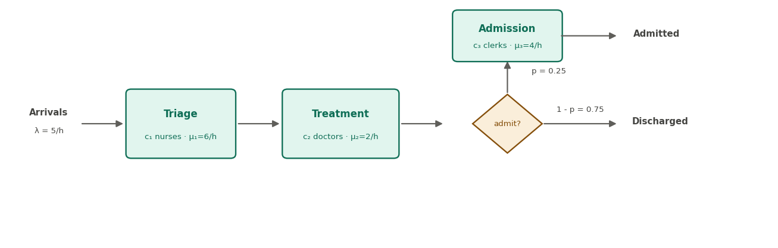
Figure 1: Emergency-department flow. Patients are triaged, treated, then admitted (probability p) or discharged.

3 Model parameters and data
Unlike a data-fitting study, the inputs here are operational rates that the analyst sets; their values are representative of a busy ED rather than estimated from one historical dataset (hypothesis SD01). The base scenario uses the values in Table 1; all of them are configurable model parameters.
Parameter | Symbol | Base value
Arrival rate | λ | 5 patients / hour
Triage service rate (per nurse) | μ₁ | 6 / hour (10 min)
Treatment service rate (per doctor) | μ₂ | 2 / hour (30 min)
Admission service rate (per clerk) | μ₃ | 4 / hour (15 min)
Triage nurses | c₁ | 1
Treatment doctors | c₂ | 3
Admission clerks | c₃ | 1
Admission probability | p | 0.25
Nurse / doctor / clerk cost | — | $40 / $150 / $30 per hour
Waiting penalty | — | $100 per patient-hour queued
The configuration parameters of a run (random seed, number of replicas, simulated horizon, warm-up) are kept separate from these model parameters, exactly as in the reference implementation.

4 Problem description
We are interested in minimising the total daily operating cost of the ED, which trades off two opposing terms: the cost of staffing the three stages, and a penalty proportional to the patient-hours spent waiting in queues (a proxy for clinical risk and dissatisfaction). Formally, the daily cost is
Cost = 24 · ( c₁ Rₙ + c₂ R_d + c₃ R_c ) + P_wait · Σᵢ Lqᵢ · 24
where Rₙ, R_d, R_c are the hourly staff rates, P_wait is the waiting penalty, and Lqᵢ is the time-average queue length at stage i. The levers available to management are the staffing levels c₁, c₂, c₃; the experimental study in Section 7 treats these as factors.

4.1 Hypotheses
To define the scope and behaviour of the model without ambiguity, the assumptions in Table 2 were made, grouped into structural (SH), simplification (SS), and data (SD) hypotheses.
Code | Type | Description
SH 01 | Structural | Patients arrive following a Poisson process (exponential inter-arrival times).
SH 02 | Structural | The ED is organised as three sequential stages: triage, treatment, admission.
SH 03 | Structural | Each stage is a multi-server station with c identical parallel servers (M/M/c).
SH 04 | Structural | Service times at every stage are exponentially distributed.
SH 05 | Structural | Every arriving patient is triaged and then sent to treatment.
SH 06 | Structural | After treatment a fixed fraction p of patients is admitted; the rest are discharged.
SH 07 | Structural | Each station serves its queue in FIFO order.
SH 08 | Structural | Queues have infinite capacity; no patient is turned away in the base model.
SH 09 | Structural | Servers are work-conserving: a free server immediately takes the next waiting patient.
SH 10 | Structural | Admission represents bed allocation/paperwork; on completion the patient leaves the system.
SS 01 | Simplification | A single, homogeneous patient class (no acuity or priority differentiation).
SS 02 | Simplification | The downstream hospital (wards, ICU) is outside the system scope.
SS 03 | Simplification | No patient abandonment (no 'left without being seen') in the base model.
SS 04 | Simplification | Staffing levels are constant over the horizon (no shift changes).
SS 05 | Simplification | The base time unit is one hour.
SS 06 | Simplification | Costs accrue linearly: a rate per staffed server-hour plus a penalty per patient-hour queued.
SS 07 | Simplification | Patients are mutually independent and do not interact.
SD 01 | Data | Arrival and service rates are representative ED values, not fitted to a specific dataset.
SD 02 | Data | The admission probability p is a fixed model parameter.
SD 03 | Data | Cost coefficients (staff rates, waiting penalty) are illustrative and configurable.

5 Model specification
The model is driven by an event-scheduling engine. Time does not advance in fixed steps; instead a Future Event List (a time-ordered priority queue) holds scheduled events, and the simulation clock jumps directly to the time of the next event. Only two event types are needed, because every change of state is a consequence of one of them:
- Arrival — a patient enters a station. If a server is free the patient starts service (a departure event is scheduled); otherwise the patient joins the FIFO queue.
- Departure — a patient finishes service at a station. The server is freed and immediately pulls the next waiting patient (scheduling its departure). The finished patient is then routed onward: to the next station, to the admission branch with probability p, or out of the system.
Patient arrivals from outside are produced by a source that schedules successive arrivals with exponential inter-arrival times. The three stations are connected through a routing function, which is what makes the model modular: returning the next station from that function turns a single queue into the multi-stage network of Figure 1, with no change to the station logic. Figure 1 doubles as the conceptual flow diagram of this process.

6 Implementation
The model is implemented in Python (event-scheduling engine and ED network) with an independent GPSS World model used for validation, and an R script for the random-number test battery. The full sources are in the appendices; the main components are described below.

6.1 Random-number generator
A Linear Congruential Generator (LCG), Xₙ₊₁ = (a Xₙ + c) mod m, produces the uniform stream U = X/m. The same generator is used by the Python model and is validated in R (Appendix B), so the randomness that is tested is exactly the randomness that drives the simulation.

6.2 Distributions and event engine
A distribution layer maps a Kendall letter to a sampler (M = exponential, D = deterministic), drawing from the LCG. The engine itself is a binary-heap Future Event List with a clock that advances event by event; scheduling an event is an O(log n) push and taking the next event an O(log n) pop.

6.3 Stations and network
A station encapsulates one M/M/c node: its servers, its FIFO queue, time-weighted accumulators for L, Lq and utilisation, and per-patient accumulators for W and Wq. A station carries a routing callback; the ED network wires triage → treatment → (admission | discharge) by supplying those callbacks, and tracks network length-of-stay on exit. A warm-up reset discards the initial transient before statistics are collected.

6.4 GPSS validation model
An equivalent model is written in GPSS World (Appendix D) using one STORAGE per stage for the c servers, QUEUE/DEPART probes for the waiting statistics, and a fractional TRANSFER for the admission branch. Because GPSS uses a different random engine and a different modelling paradigm (transaction flow), agreement of the metrics is independent evidence that both implementations are correct.

7 Definition of the experimental framework

7.1 Experiment definition
The study examines how staffing decisions affect the daily operating cost. We use three factors at two levels each — the number of servers at each stage — chosen so that every corner of the design is a stable queue (utilisation below one at all stages).
Factor | Description | Low (−) | High (+)
A | Doctors at Treatment (c₂) | 3 | 4
B | Nurses at Triage (c₁) | 1 | 2
C | Clerks at Admission (c₃) | 1 | 2
This is a full factorial 2³ design: 8 scenarios, each run with 4 replicates (different random seeds) to account for simulation randomness, for 32 runs in total. Each run simulates 2000 hours after a 200-hour warm-up. The response is the daily operating cost defined in Section 4.

7.2 Results analysis
Table 3 lists the cost (in $/day) of the four replicas of each scenario and their mean. Scenarios are listed in Yates standard order.
Run | A | B | C | Y1 | Y2 | Y3 | Y4 | Mean
(1) | − | − | − | 31,195 | 32,251 | 31,750 | 31,944 | 31,785
a | + | − | − | 30,775 | 28,947 | 30,314 | 28,701 | 29,684
b | − | + | − | 24,151 | 22,661 | 24,804 | 22,769 | 23,596
ab | + | + | − | 19,034 | 19,159 | 18,997 | 18,947 | 19,035
c | − | − | + | 31,197 | 31,918 | 31,942 | 29,797 | 31,213
ac | + | − | + | 29,926 | 28,669 | 25,514 | 26,614 | 27,681
bc | − | + | + | 22,908 | 21,953 | 24,035 | 21,163 | 22,515
abc | + | + | + | 19,632 | 19,404 | 19,658 | 19,556 | 19,563
Applying Yates' algorithm gives the effect of each factor and interaction; an ANOVA (24 error degrees of freedom) tests their significance at α = 0.05. The results are in Table 4 (grand mean = $25,634/day).
Term | Effect ($/day) | Sum of squares | F | p-value | Sig.
A | −3,287 | 86,417,497 | 78.06 | <0.0001 | ***
B | −8,914 | 635,649,940 | 574.14 | <0.0001 | ***
C | −470 | 1,768,937 | 1.60 | 0.218
AB | −782 | 4,893,382 | 4.42 | 0.046 | *
AC | +44 | 15,745 | 0.01 | 0.906
BC | +505 | 2,043,518 | 1.85 | 0.187
ABC | +760 | 4,625,391 | 4.18 | 0.052
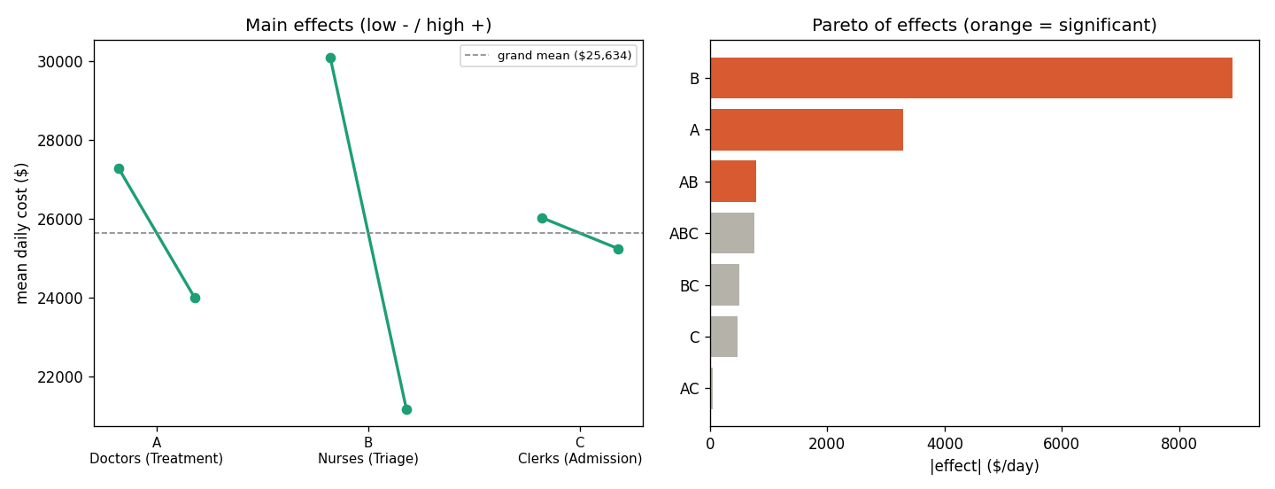
Figure 2: Main-effects plot (left) and Pareto of effects (right). Orange bars are significant at α = 0.05.
The dominant effect is B (triage nurses): a second nurse reduces cost by about $8,900/day, because triage at a single nurse is heavily congested and a nurse is inexpensive. Treatment doctors (A) are next, reducing cost by about $3,300/day, and there is a significant A×B interaction. The number of admission clerks (C) has no significant effect: the admission stage is lightly loaded, so a second clerk is wasted spending. The cost-minimising configuration is scenario ab (4 doctors, 2 nurses, 1 clerk) at $19,035/day, roughly 40% below the base configuration.

8 Model validation
A modelling project passes through three phases — conceptual modelling, implementation and simulation, and operational use — each requiring appropriate validation techniques. We organise the validation along the framework of Fonseca i Casas (2023), selecting techniques suited to this project's stage.

8.1 Conceptual modelling phase
Traceability assessment. Table 5 links each structural hypothesis to the model component that implements it and to the simulation goal it serves (G1 = estimate congestion and length of stay; G2 = find the cost-minimising staffing policy; G3 = enable analytical validation). The matrix confirms that every assumption is realised in the model and that no component is unmotivated.
Hypothesis | Model component | Goal
SH 01 (Poisson arrivals) | Source + exponential Distribution | G1, G3
SH 02 (three stages) | EDNetwork wiring triage→treatment→admission | G1
SH 03 (c servers per stage) | Station server count / GPSS STORAGE | G2
SH 04 (exponential service) | Distribution.sample (M) | G3
SH 06 (admission branch) | EDNetwork routing (probability p) | G1
SH 07 (FIFO) | Station FIFO queue | G1
SH 08 (infinite capacity) | no rejection logic | G3 (keeps it a Jackson network)
SS 06 (linear costs) | cost function | G2
SD 02 (admission probability) | model parameter p | G1
Inspection and walkthrough. The system description, the hypotheses table, and the flow diagram (Figure 1) are the documents reviewed in a structured peer inspection; the flow diagram is also used to walk stakeholders through the model logic step by step, surfacing ambiguities before implementation.

8.2 Implementation and simulation phase
Semantic analysis. The event-scheduling logic has an explicit, deterministic event order (arrival → service start → departure, with FIFO selection), which was reviewed against the conceptual model to confirm internal consistency.
Sensitivity analysis. The 2³ design of Section 7 is itself a structured sensitivity analysis: it varies the staffing parameters and measures the response, and the ranking of effects it produces is consistent with queueing intuition (the lightly loaded stage is the insignificant factor).
Execution testing. We monitored a state variable — the number of patients in the ED — over time for an understaffed and a well-staffed scenario (Figure 3). The system fills from empty and stabilises around the expected congestion level, and adding staff visibly lowers it (mean ≈ 10 patients understaffed versus ≈ 4 well-staffed), confirming that the model behaves as intended.
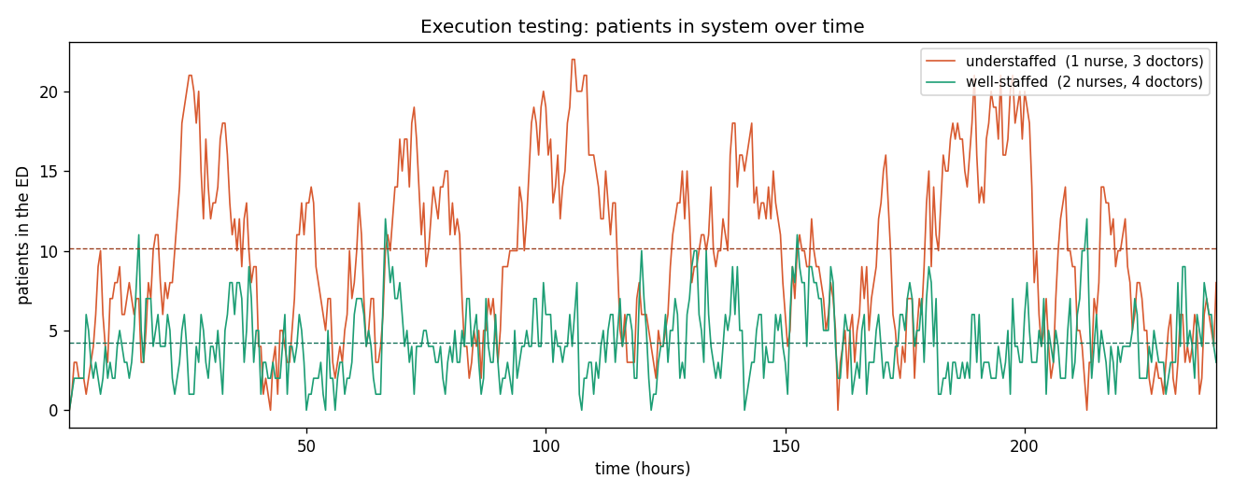
Figure 3: Execution testing. Patients in the ED over time, understaffed vs well-staffed. Dashed lines mark the post-warm-up means.
RNG verification (mandatory). The LCG was submitted to a statistical test battery; Table 6 reports a numeric cross-check in Python (the full randtoolbox battery — frequency, serial, gap, poker, order — is in Appendix B). The generator shows no significant departure from uniformity or independence.
Test | Result | Verdict
Mean of 10,000 draws | 0.4984 (target 0.5) | pass
Variance | 0.0837 (target 0.0833) | pass
Chi-square uniformity | p = 0.568 | pass
Kolmogorov–Smirnov | p = 0.765 | pass
Runs (up/down) | p = 0.770 | pass
Lag-1 autocorrelation | +0.0003 (target ≈ 0) | pass

8.3 Operational use phase
Comparison testing. Because every stage is M/M/c with Poisson input and exponential service, the network is a Jackson network with a closed-form steady state. Table 7 compares the simulation (60,000-hour run) with the Jackson solution; agreement is within about 1% on the busy stages and the network length of stay matches to 0.2%. The independent GPSS model (Appendix D) reproduces the same base scenario with a different random engine.
Station | Metric | Simulation | Theory | Error %
Triage | ρ | 0.831 | 0.833 | 0.3
Triage | L | 5.026 | 5.000 | 0.5
Triage | Lq | 4.196 | 4.167 | 0.7
Triage | W (h) | 1.006 | 1.000 | 0.6
Treatment | ρ | 0.832 | 0.833 | 0.1
Treatment | L | 5.992 | 6.011 | 0.3
Treatment | Lq | 3.496 | 3.511 | 0.4
Treatment | W (h) | 1.200 | 1.202 | 0.2
Admission | ρ | 0.314 | 0.313 | 0.5
Admission | L | 0.460 | 0.455 | 1.2
Network | Length of stay (h) | 2.298 | 2.293 | 0.2
Network | Total L | 11.479 | 11.466 | 0.1
Path analysis. Following one admitted patient through the event trace exposes the causal chain the model is meant to reproduce — a saturated stage forces a queue, the wait delays service, and the patient is then routed onward. The trace below is patient p5 (admitted):
[t= 0.850] ARRIVE p5 -> Triage QUEUE busy=1/1 q=2 (all nurses busy -> waits)
[t= 1.974] DEPART p5 <- Triage (queued ~1.1 h)
[t= 1.974] route p5 Triage -> Treatment
[t= 1.974] ARRIVE p5 -> Treatment SERVICE busy=2/3 (doctor free -> no wait)
[t= 2.272] DEPART p5 <- Treatment
[t= 2.272] route p5 Treatment -> Admission (admitted, p = 0.25)
[t= 2.272] ARRIVE p5 -> Admission SERVICE busy=1/1
[t= 2.317] DEPART p5 <- Admission (leaves system; length of stay 1.47 h)
The sequence (queue at triage → wait → service → treatment → admission → exit) matches the intended cause-and-effect, providing evidence through path analysis.
Acceptance testing. The model, its assumptions, and these results are presented to the stakeholders (the course instructors) to confirm that the behaviour and outputs meet the intended requirements — the final validation of the model's credibility.

9 Conclusions
We developed a discrete-event simulation of an emergency department as a three-stage open queueing network, driven by a validated random-number generator and built on a modular event-scheduling engine. A full-factorial 2³ study showed that triage nurses and treatment doctors are the decisive levers on operating cost, with a significant interaction between them, while admission staffing is immaterial; the best configuration tested cut daily cost by about 40%.
The model was validated along all three phases of the VV&A framework, and notably the experimental conclusions agree with the congestion predicted analytically by queueing theory — the experiment and the validation reinforce each other. Future work could relax simplifying assumptions (patient acuity classes, abandonment, shift-varying staffing, finite waiting room) and widen the design to more factors and levels, and could compute confidence intervals on the estimated effects.

Appendix A Project repository
⟨ insert the git repository URL here ⟩

Appendix B Random-number validation (prng_validation.R)
⟨ paste the contents of prng_validation.R here ⟩

Appendix C Simulation model (ed_simulation.py)
⟨ paste the contents of ed_simulation.py here ⟩

Appendix D GPSS validation model (ed_model.gps)
⟨ paste the contents of ed_model.gps here ⟩

Appendix E Experimental design (ed_doe.py)
⟨ paste the contents of ed_doe.py here ⟩

Appendix F Execution testing and path analysis (ed_trace_analysis.py)
⟨ paste the contents of ed_trace_analysis.py here ⟩

